**Graded Assignment Screenshots:**

1. Home page looks like

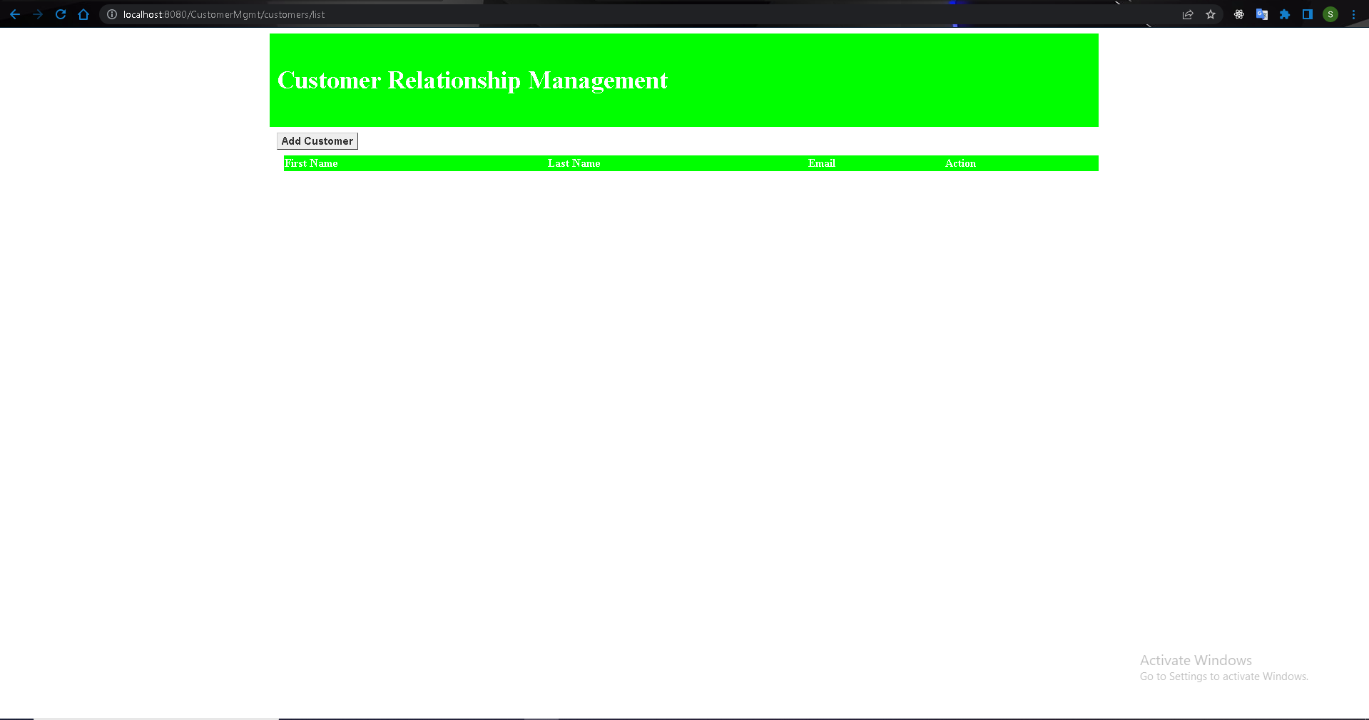

1. Click on Add customer button.

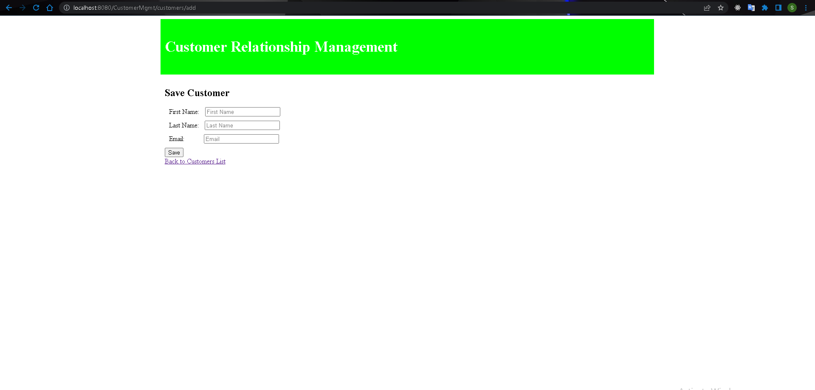

1. Enter data

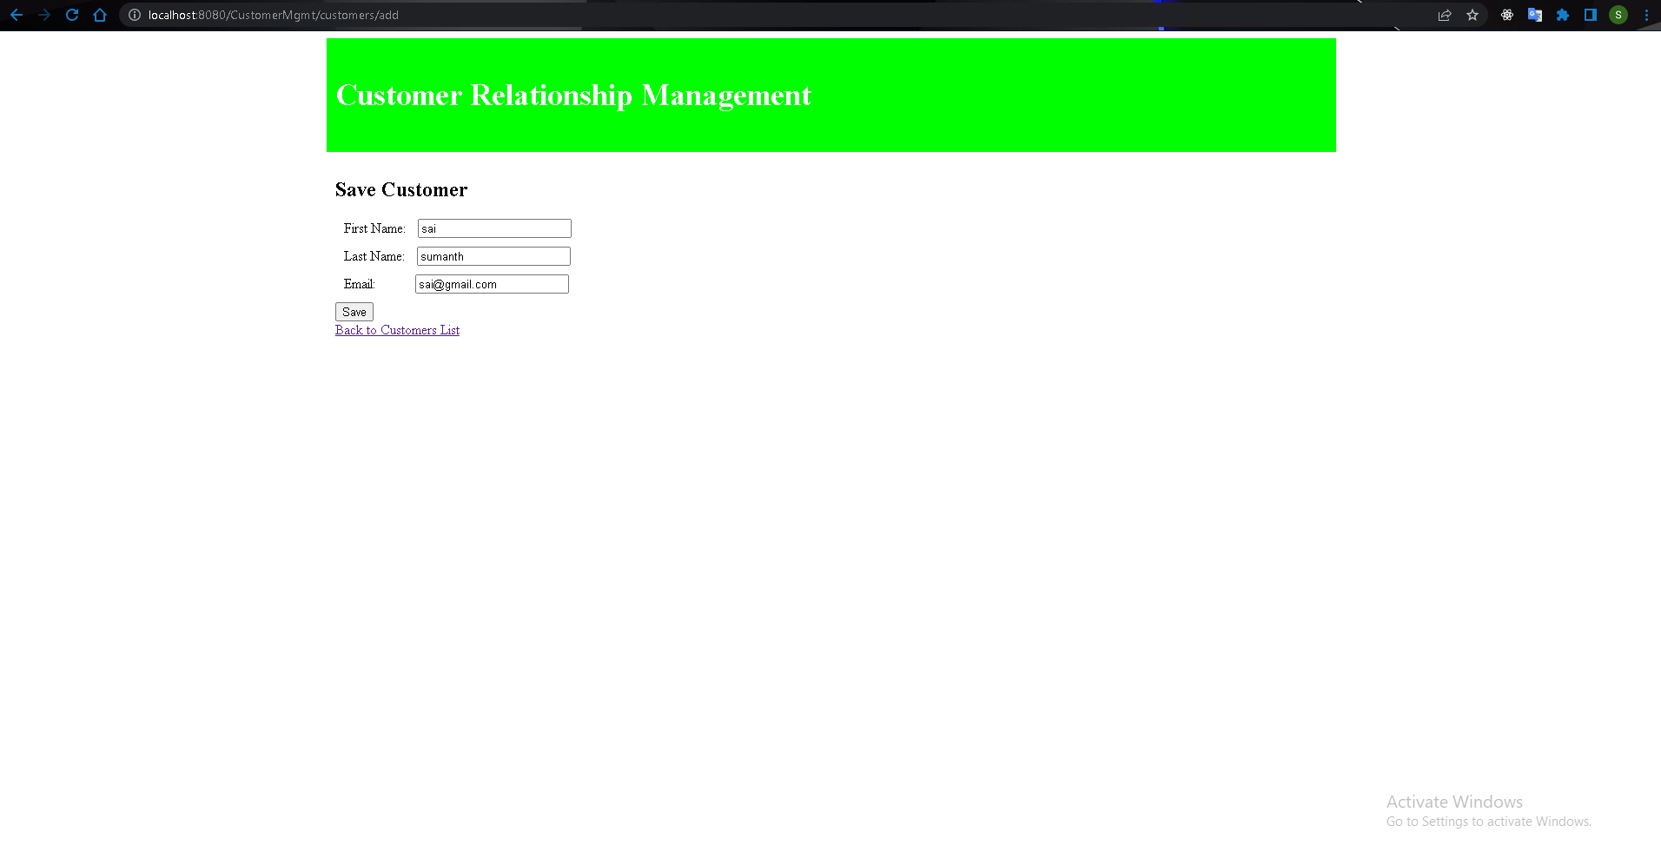

1. Click on save.User is redirected back to home page and user created is shown.

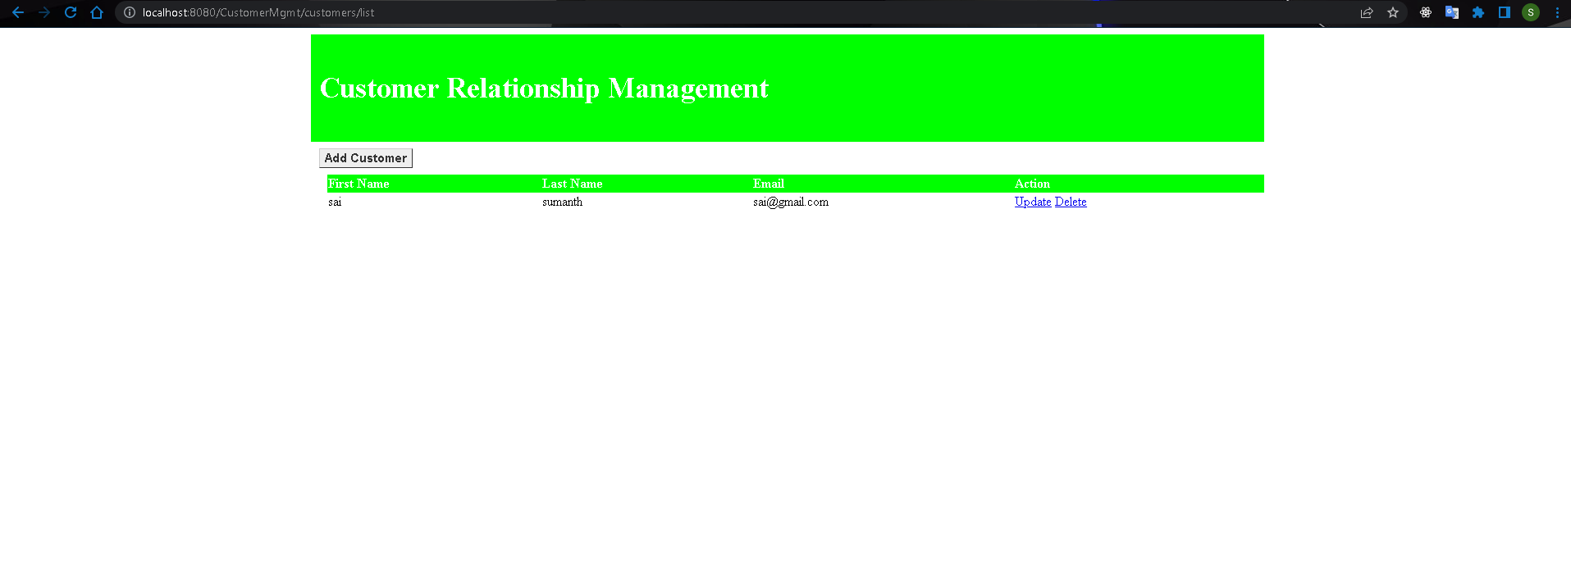

1. Click on update.

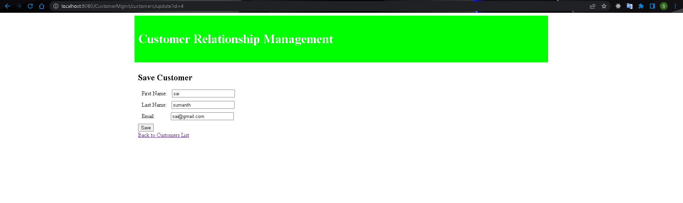

1. User is taken to this screen, and customer data is shown.
2. Update data .

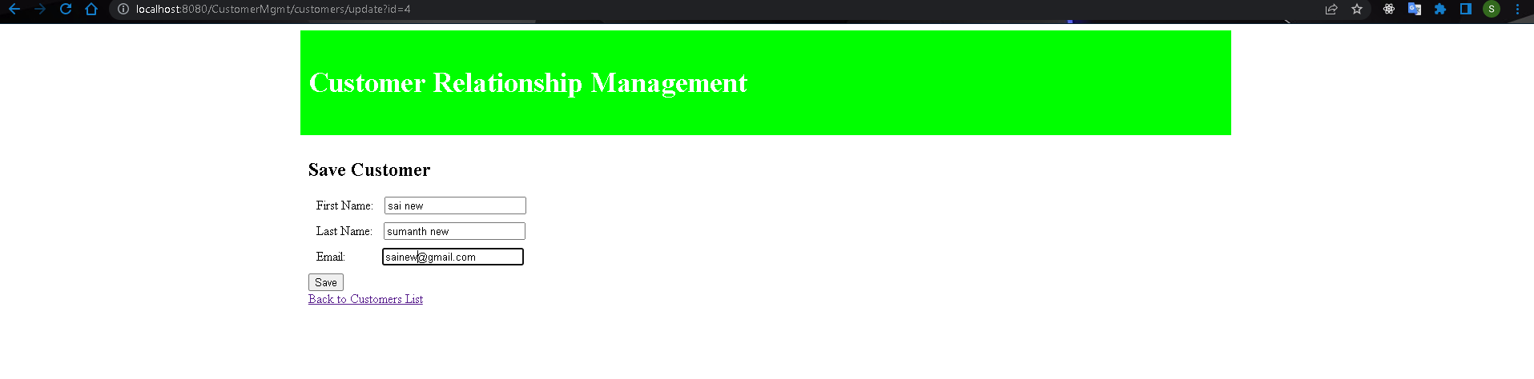

1. Click on save…Updated data is seen.

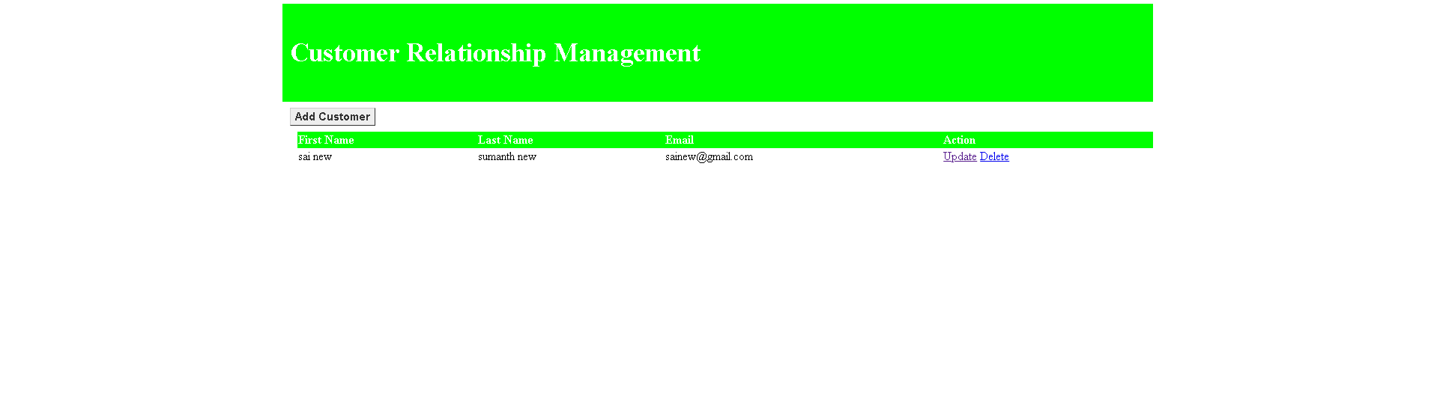

1. Click on delete.Alter popup is shown.

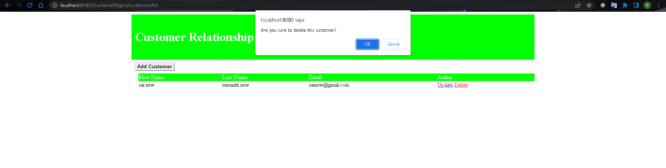

1. Click ok. Record is deleted.

